Intel® Smart Connect Technology

Compliance Test Plan

November 2013

Revision 1.4

Intel Confidential

INFORMATION IN THIS DOCUMENT IS PROVIDED IN CONNECTION WITH INTEL PRODUCTS. NO LICENSE, EXPRESS OR IMPLIED, BY ESTOPPEL OR OTHERWISE, TO ANY INTELLECTUAL PROPERTY RIGHTS IS GRANTED BY THIS DOCUMENT. EXCEPT AS PROVIDED IN INTEL'S TERMS AND CONDITIONS OF SALE FOR SUCH PRODUCTS, INTEL ASSUMES NO LIABILITY WHATSOEVER AND INTEL DISCLAIMS ANY EXPRESS OR IMPLIED WARRANTY, RELATING TO SALE AND/OR USE OF INTEL PRODUCTS INCLUDING LIABILITY OR WARRANTIES RELATING TO FITNESS FOR A PARTICULAR PURPOSE, MERCHANTABILITY, OR INFRINGEMENT OF ANY PATENT, COPYRIGHT OR OTHER INTELLECTUAL PROPERTY RIGHT.   
  
A "Mission Critical Application" is any application in which failure of the Intel Product could result, directly or indirectly, in personal injury or death. SHOULD YOU PURCHASE OR USE INTEL'S PRODUCTS FOR ANY SUCH MISSION CRITICAL APPLICATION, YOU SHALL INDEMNIFY AND HOLD INTEL AND ITS SUBSIDIARIES, SUBCONTRACTORS AND AFFILIATES, AND THE DIRECTORS, OFFICERS, AND EMPLOYEES OF EACH, HARMLESS AGAINST ALL CLAIMS COSTS, DAMAGES, AND EXPENSES AND REASONABLE ATTORNEYS' FEES ARISING OUT OF, DIRECTLY OR INDIRECTLY, ANY CLAIM OF PRODUCT LIABILITY, PERSONAL INJURY, OR DEATH ARISING IN ANY WAY OUT OF SUCH MISSION CRITICAL APPLICATION, WHETHER OR NOT INTEL OR ITS SUBCONTRACTOR WAS NEGLIGENT IN THE DESIGN, MANUFACTURE, OR WARNING OF THE INTEL PRODUCT OR ANY OF ITS PARTS.   
  
Intel may make changes to specifications and product descriptions at any time, without notice. Designers must not rely on the absence or characteristics of any features or instructions marked "reserved" or "undefined". Intel reserves these for future definition and shall have no responsibility whatsoever for conflicts or incompatibilities arising from future changes to them. The information here is subject to change without notice. Do not finalize a design with this information.   
  
The products described in this document may contain design defects or errors known as errata which may cause the product to deviate from published specifications. Current characterized errata are available on request.   
  
Contact your local Intel sales office or your distributor to obtain the latest specifications and before placing your product order.   
  
Copies of documents which have an order number and are referenced in this document, or other Intel literature, may be obtained by calling 1-800-548-4725, or go to: [http://www.intel.com/design/literature.htm](http://www.intel.com/design/literature.htm%20" \t "_blank)

Chief River and other code names featured are used internally within Intel to identify products that are in development and not yet publicly announced for release. Customers, licensees and other third parties are not authorized by Intel to use code names in advertising, promotion or marketing of any product or services and any such use of Intel's internal code names is at the sole risk of the user.

IntelCore, Intel Management Engine (Intel ME), Intel Rapid Start Technology, Intel Smart Connect Technology, Intel and the Intel logo are trademarks of Intel Corporation in the U.S. and/or other countries.

\*Other names and brands may be claimed as the property of others.

Copyright © 2013, Intel Corporation. All rights reserved.

Contents

1 Introduction 7

1.1 Purpose of this Document 7

1.2 Reference Documents 7

2 Configuration 8

3 Intel® Smart Connect Technology Compliancy Tool 9

3.1 Compliancy Test Settings: 10

3.2 Battery Life Test: 14

3.3 Periodic Cycle Test: 14

3.4 Brand Test 16

4 Intel® Smart Connect Technology Interface Exerciser 18

5 Installation 19

6 BIOS/EC/HW 20

6.1 Objective 20

7 Basic Functionality 22

7.1 Objective 22

8 System Thermal Testing 26

8.1 Objective 26

9 NetDetect 28

9.1 Objective 28

10 Intel® Rapid Start Technology 33

10.1 Objective 33

11 Remote Wake 34

11.1 Objective 34

Figures

Figure 2‑1. Test Setup 8

Figure 3‑1. Intel® Smart Connect Technology Compliancy Tool UI 10

Figure 3‑2. Test Settings Dialog Box 11

Figure 3‑3. Compliancy Test Settings for Periodic Wake 12

Figure 3‑4. Compliancy Test Settings for NetDetect 13

Figure 3‑5. Successful Test Results 15

Figure 3‑6. Failed Test Results 16

Figure 4‑1. Intel® Smart Connect Technology Interface Exerciser 18

Tables

Table 5-1. Installation Verification 19

Table 6-1. BIOS/EC/HW Verification 20

Table 7-1. Basic Functionality Verification 22

Table 7-1. System Thermal Testing 27

Table 9-1. NetDetect Verification 28

Table 10-1. Intel® Rapid Start Technology Verification 33

Table 10-1. Intel® Remote Wake from S3 Power State 34

Revision History

|  |  |  |  |
| --- | --- | --- | --- |
| Document Number | Revision Number | Description | Revision Date |
| 515425 | 0.5 | * Initial release | November 2012 |
| 0.8 | * Updated Basic Functionality test (BAS-011) as optional test (Chapter 5) * Updated Intel® Smart Connect Technology Compliancy Tool (Chapter 11) December 2012 | December 2012 |
| 0.9 | * Updated test BAT 001 for 15% battery degradation (Chapter 6) * Updated test BAS-016 PwrTest formula for 1200 seconds (Chapter 5) * Added Brand Test in Intel® Smart Connect Technology Compliancy Tool (Chapter 11.4) | January 2013 |
|  | 1.0 | * Updated through out document that internet connectivity is required to run tests | April 2013 |
|  | 1.1 | * Replaced the basic test section with usage of iSCTChecker.exe * Noted tests that are not required for Bay Trail M/D platform * Removed battery threshold test section and thermal threshold setting test as those tests were part of the Intel validation of the Intel® Smart Connect Technology Agent * Added test BAS-017 for platforms with a physical radio on/off switch * Updated power button/power button override testing when system is in S0-ISCT * Updated test setup requirements for Remote Wake | June 2013 |
|  | 1.2 | * Updated tests BAS-010 and BAS-014 and removed test case BAS-011 as the test was merged into the BAS-010 test * Removed Remote Wake test cases that did not test for platform functionality | July 2013 |
|  | 1.3 | * Added note that running THRM-001 test on battery when SUT is in heat chamber is allowed | August 2013 |
|  | 1.4 | * Changed Remote Wake tests performed to use WakeMyPC * Baytrail M/D supports Remote Wake | November 2013 |

§

# Introduction

## Purpose of this Document

The Intel® Smart Connect Technology Compliance Guide is designed to provide original equipment and device manufacturers with the compliancy requirements for platform implementation and the methodology and tools to verify compliance Intel® Smart Connect Technology. This document contains the compliance requirements to meet Intel® Smart Connect Technology quality requirements. This will reduce the number of issues seen in the implementation of this technology.

It also provides the test environment setup information, the procedure for each test, and the expected results for the purpose of validating compliancy. Requirements contained in this document target the system BIOS/EC and other aspects of overall platform implementation.

Any issues found within Intel® Smart Connect Technology should be promptly reported to your Intel contact for further assessment.

1. Intel® Smart Connect Technology is referred to (for brevity) as “ISCT” in various table entries throughout this document.

Some of the tests may require changes to the registry. If changes are made, a restart of the ISCT Agent is required. This can be accomplished by rebooting the system under test (SUT).

## Reference Documents

| Document | Document No./Location |
| --- | --- |
| *Intel® Smart Connect Technology Platform Design Specification* | 503702 |
| *Intel® Smart Connect Technology Setup & Configuration Guide* | 515415 |
| *Intel® Smart Connect Technology Compliancy Test Kit (for tools referenced in this document)* | VIP |
| *Intel® Smart Connect Technology using WakeMyPC* | 514347 |

§

# Configuration

Test setup is pictured below. For the tests described in the test plan, the connection from the system under test (SUT) to the content server can be over a wired connection. The content server or router/gateway will need to supply the IP address for the SUT. The Wireless Access Point (AP) is required for the NetDetect testing section. If the AP has security enabled, before conducting these tests ensure the SUT is configured properly and has connectivity.

***Note:*** An Internet connection is required for the tests to run. Without an Internet connection, periodic wake by timer will not work and NetDetect will be enabled. The network connection needs to not require a Proxy Server to be configured and the network connection has no hidden Proxy Servers that would block external access for the Remote Wake tests.

The configuration values for Intel® Smart Connect Technology should be configured with the settings the customer plans to ship (periodic wake, OS unattended sleep, password required on resume). For battery tests, battery is fully charged.

Figure ‑. Test Setup

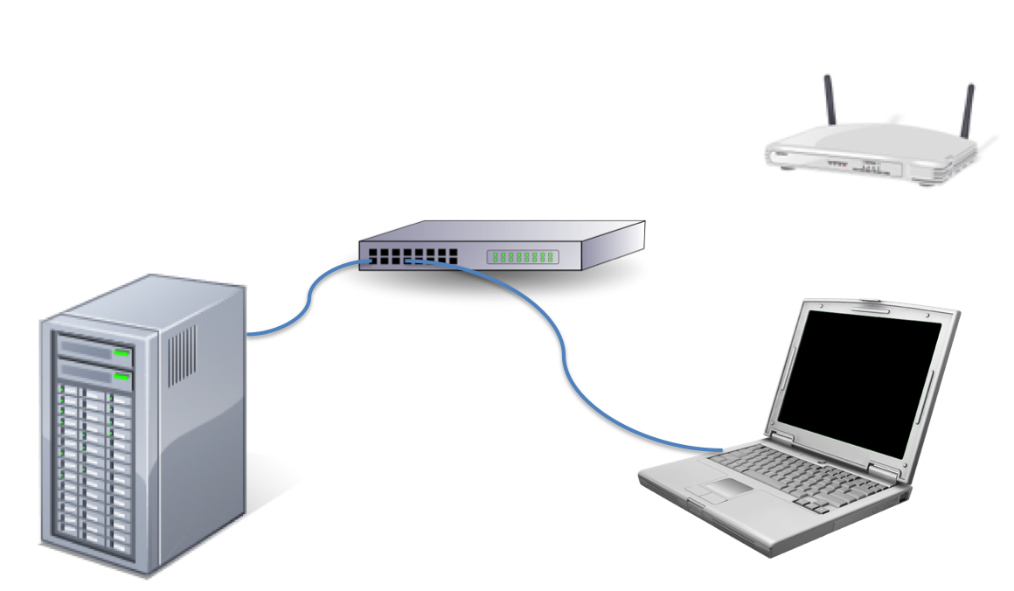

# Intel® Smart Connect Technology Compliancy Tool

This tool provides a method for the BIOS developer and Validation team to verify their platform correctly supports Intel® Smart Connect Technology. The tool can test for Intel® Smart Connect Technology Compliancy, Periodic Cycle and Battery life tests. The tool is provided with the Intel® Smart Connect Technology Compliancy Kit.

Verify system is configured/connected to a network with Internet connectivity to run these tests.

Make sure the tool is run from the hard disk of the SUT and not a USB key.

Upon invocation of iSCTChecker.exe the following is displayed:

Figure ‑. Intel® Smart Connect Technology Compliancy Tool UI

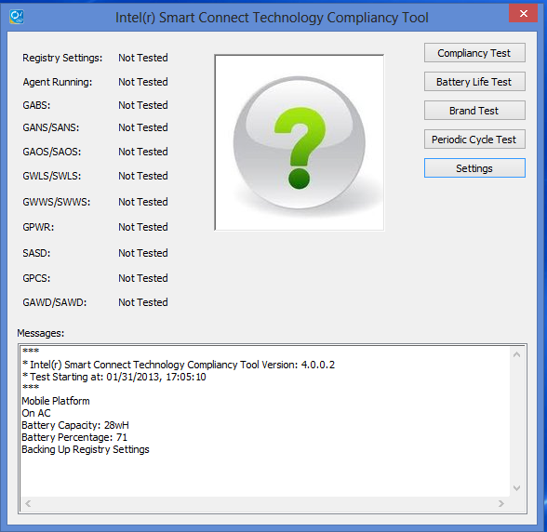

The left side of the GUI displays the compliancy tests that are run The **Messages** window displays the platform configuration and output of the tests on each of the compliancy tests. All information displayed in the **Messages** window is also saved in the log file named iSCTChecker\_Log.txt file.

## Compliancy Test Settings:

The **Settings** button displays the test configuration dialog box:

Figure ‑. Test Settings Dialog Box

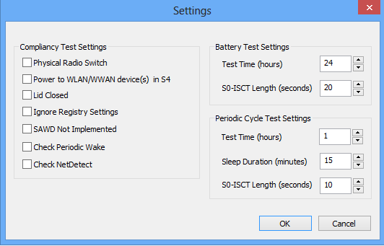

* “Physical Radio Switch” checkbox:
  + Checks GABS for correct reporting of this setting
  + Select this checkbox if the platform has a physical radio on/off switch
* “Power to WLAN/WWAN device(s) in S4” checkbox:
  + Checks GABS for correct reporting of this setting
  + Select this checkbox if power is available to the comms devices in S4
* “Lid Closed” checkbox:
  + Checks GPCS ACPI method for lid closed status
  + Select checkbox during testing if implementing  “Lid Closed”
* “Ignore Registry Settings (Non-Production)”:
  + If checked, does not verify registry settings contain debug values
  + In Production environment this is not checked
* “SAWD not implemented” checkbox:
  + Does not checks for GAWD/SAWD ACPI method
  + Select checkbox if GAWD/SAWD ACPI method not supported
* “Check Periodic Wake” checkbox:
  + Select checkbox to perform a short (2 minute) sleep duration and check for correct GPWR ACPI method return value
* “Check NetDetect” checkbox:
  + Select checkbox to perform NetDetect and check for correct GPWR ACPI method return value

In this example the following settings are used:

1. Test Compliance Test to check BIOS parameters
2. The platform does not have a physical Radio On/Off switch
3. Power is not supplied to the Comms devices in S4
4. Lid is open
5. Ignore registry setting
6. SAWD not implemented
7. Closing the dialog returns back to the main (opening) window
8. When the “Compliance Test” button is pressed, the tests are run using the settings and the following window displayed if all tests pass (Figure 3‑5)

Figure ‑. Compliancy Test Settings for Periodic Wake

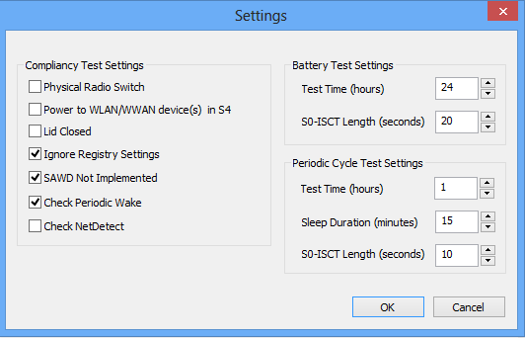

In this example the following settings are used:

1. Test Compliance Test to check BIOS parameters
2. The platform has a physical Radio On/Off switch
3. Power is not supplied to the Comms devices in S4
4. Lid is open
5. Ignore registry setting
6. SAWD not implemented
7. Check Periodic Wake
8. Closing the dialog returns back to the main (opening) window
9. When the “Compliance Test” button is pressed, the tests are run using the settings and the following window displayed if all tests pass (Figure 3‑5)

In this test GPWR return value is tested for Periodic Timer Wake. Compliancy Test will configure registry settings for 2 minute sleep duration, put platform into S3 and then upon wake, check the GPWR result for the correct settings.

Figure ‑. Compliancy Test Settings for NetDetect

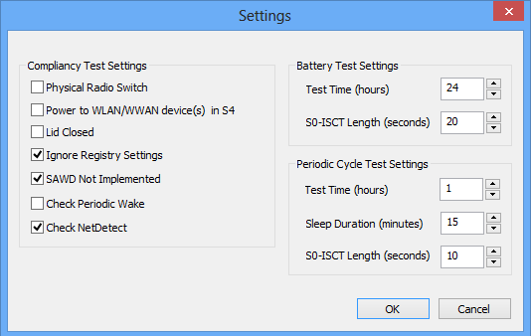

In this example the following settings are used:

1. Test Compliance Test to check BIOS parameters
2. The platform has a physical Radio On/Off switch
3. Power is not supplied to the Comms devices in S4
4. Lid is open
5. Ignore registry setting
6. SAWD not implemented
7. Check NetDetect
8. Closing the dialog returns back to the main (opening) window
9. When the “Compliance Test” button is pressed, the tests are run using the settings and the following window displayed if all tests pass (Figure 3‑5)

In this test GPWR return value is tested for NetDetect Wake. To run this test, perform the following:

1. Make sure your Access Point is not turned on. The Compliancy test will verify this upon invocation of the test.
2. Click the “Compliancy Test” button to start the test.
   1. The test will check the ACPI interfaces to verify correctness.
   2. The test will configure a 2 minute sleep duration for the Agent to be woken in a non-network configuration to configure NetDetect.
3. After about 5 minutes, apply power to the Access Point
4. Within 1 to 2 minutes, the platform will wake. Allow the tool about 2 minutes to update the result (pass/fail).

## Battery Life Test:

This test is for battery life reduction over a set time. Verify system is configured/connected to a network with Internet connectivity to run this test.

In this test, the following settings are used:

1. Periodic wake set to 15 minute sleep duration
2. No white list enabled
3. Nighttime hours of 10:00 PM to 6:00 AM
4. Wake duration of 22-27 seconds
5. Battery fully charged (>95% capacity)
6. Run test for 24 hours on battery
7. After 24 hours, passing state will be no more than 15% battery degradation

## Periodic Cycle Test:

This test is for testing Periodic Wake Tests in Cycles (Periodic Cycle Test). Verify system is configured/connected to a network with Internet connectivity to run this test.

In this test, the following settings are used:

1. Periodic wake set to 15 minute sleep duration
2. No white list enabled
3. Nighttime hours of 10:00 PM to 6:00 AM
4. Select Test Time Hours minimum of 1 hour
5. Sleep duration minimum of 1 minute
6. Wake duration of 10 seconds
7. System is connected to AC
8. Run the Periodic Cycle Test
9. Check log file to confirm system completed periodic wake test

Figure ‑. Successful Test Results

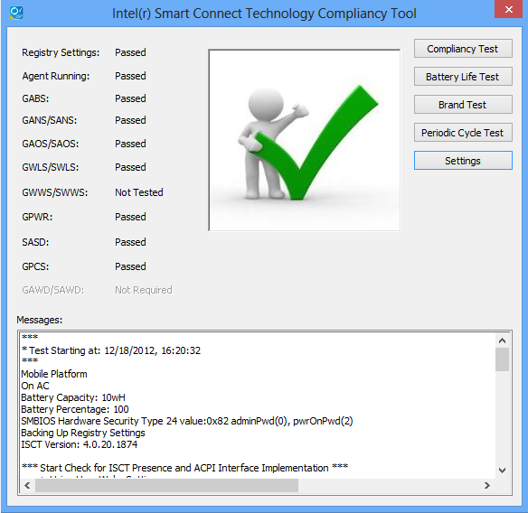

If any of the tests fail, instead of the checkmark icon being displayed, an icon with an “X” is displayed. In this example, the Physical Radio On/Off GABS ACPI Control Method setting was set not correctly as indicated in the Messages window.

Figure ‑. Failed Test Results

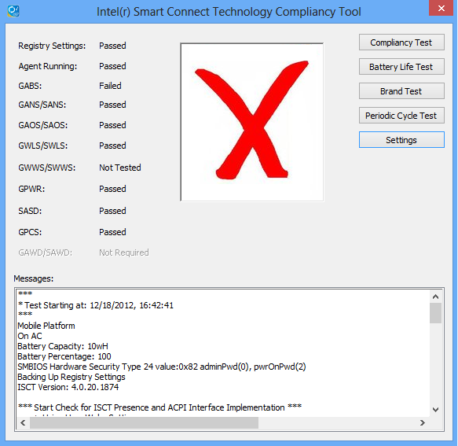

## Brand Test

This test is to confirm if platform/system meets the Intel® Ultrabook compliancy requirements for Intel® Smart Connect Technology. Please run this test on a fresh install, and the settings should remain same as used in regular compliance testing.

***Note:*** An Internet connection is required for periodic wake to work correctly.

In this test, the following steps are required:

* + - * 1. Reboot platform
        2. Make sure test platform is on battery power only
        3. Invoke iSCTChecker tool
        4. Verify iSCTChecker settings meets platform compliancy test settings

**Note**: Battery Test and Periodic Cycle Test settings are ignored. In the Compliancy Test Settings, Check Periodic Wake must be checked.

* + - * 1. Make sure all applications except iSCTChecker tool are closed

**Note:** Whitelist is temporarily disabled for this test

* + - * 1. Run Brand Test

Please note: test will run for 24 hours and will create XML file at the end of the test which will be used by the ULT. Prompt will confirm completion of the Brand Test (Pass/Fail) with indication of Battery Life Percentage used during the 24 hour test.

§

# Intel® Smart Connect Technology Interface Exerciser

For manual testing of the BIOS ACPI methods, the ISCT Interface Exerciser allows invocation of each required BIOS ACPI interface interactively.

Upon invoking pnpExerciser.exe the following window is displayed:

Figure ‑. Intel® Smart Connect Technology Interface Exerciser

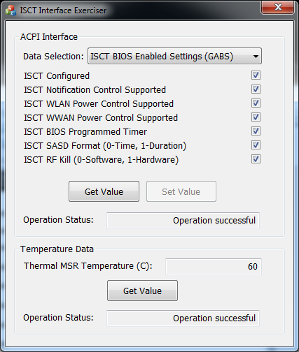

To check additional functions, click on the Data Selection drop down to select other functions.

§

# Installation

Table 5-1. Installation Verification

| Test Case | Objective | Test Procedure | Pass/Fail Criteria |
| --- | --- | --- | --- |
| INS-001 | Verify ISCT virtual device is created | 1. Boot into BIOS menu of the SUT and turn on ISCT (optional if BIOS doesn't support this feature) 2. Locate an "Unknown device" with Hardware ID "ACPI\INT33A0" from windows device manager | Device with Hardware ID "ACPI\INT33A0" should not exist if boot with ISCT disabled |
| INS-002 | Verify that ISCT can be installed on your SUT properly | 1. Un-install previous installation if exists 2. Open windows explorer and navigate to ISCT installation directory 3. Execute "Setup.exe" as Administrator 4. Follow the GUI instructions to complete installation | 1. Installation complete without error message.  2. Check Windows Service Manager and verify ISCT agent is started |
| INS-003 | Verify ISCT device is consumed in device manager properly by the driver | 1. Execute Windows\* Device Manager 2. Expand "System devices" and try locating "Intel(R) Smart Connect Technology Device" | ISCT device existed and version matched |
| INS-004 | Verify ISCT Agent is installed | 1. Open a Command Prompt with Administrator privilege 2. Execute "Net Stop ISCTAgent" 3. Execute "Net Start ISCTAgent" | Command should complete without error message |
| INS-005 | Verify all drivers resume properly when waking from S3 | 1. Open Device Manager and make sure no yellow bang exists on ISCT device 2. Put SUT in S3 state 3. Wake up SUT by power button 4. Verify S3 resume correctly and there is no yellow band devices in Windows Device Manager | S3 cycle complete with  error message |

§

# BIOS/EC/HW

## Objective

Verify BIOS/EC/HW supports the required platform interfaces of Intel® Smart Connect Technology.

Tests in this section are verified with the Intel® Smart Connect Technology Compliancy Tool (iSCTChecker.exe) and Intel® Smart Connect Technology Interface Exerciser (pnpExerciser.exe). Refer to the respective sections for information on running the tools.

Select “Periodic Wake Test” in the Settings dialog along with other platform settings for the tests that indicate using iSCTChecker.exe.

Table 6-1. BIOS/EC/HW Verification

| Test Case | Objective | Test Procedure | Pass/Fail Result |
| --- | --- | --- | --- |
| BES-001 | Verify GABS  ACPI method | Run Compliancy Test option of iSCTChecker.exe |  |
| BES-002 | Verify GAOS/SAOS  ACPI method | Run Compliancy Test option of iSCTChecker.exe |  |
| BES-003 | Verify GANS/SANS  ACPI method | Run Compliancy Test option of iSCTChecker.exe |  |
| BES-004 | Verify GWLS  ACPI method | Run Compliancy Test option of iSCTChecker.exe | Test not required if no WLAN power control |
| BES-005 | Verify GWWS ACPI method | Run Compliancy Test option of iSCTChecker.exe | Test not required if no WWAN power control |
| BES-006 | Verify SASD  ACPI method | Run Compliancy Test option of iSCTChecker.exe |  |
| BES-007 | Verify GPWR ACPI method | Run Compliancy Test option of iSCTChecker.exe |  |
| BES-008 (Mobile Only) | Verify GPCS ACPI Method | Connect an external monitor and keyboard to the SUT and close the lid  Select “Lid Closed” setting in the Settings dialog  Run Compliancy Test option of iSCTChecker.exe |  |
| WLAN-001 | Verify SWLS  ACPI method | 1. Select "WLAN Module Status (GWLS/SWLS)" in pnpExcerciser tool 2. Check "WLAN Powered in S3 Enabled" 3. Select "Set Value" 4. Stop the Intel® Smart Connect Technology Agent in the Services Control Manager 5. Put platform into S3 and verify power is applied to WLAN module in S3 6. Repeat steps 2-4 with S4 sleep state if supported 7. Start the Intel® Smart Connect Technology Agent in the Services Control Manager | Test not required if no WLAN power control (non-mobile) |
| WWAN-001 | Verify SWWS ACPI method | 1. Select "WWAN Module Status( GWWS/SWWS)" in pnpExcerciser tool 2. Check "WWAN Powered in S3 Enabled" 3. Select "Set Value" 4. Put platform into S3 and verify power is applied to WWAN module in S3 5. Repeat steps 2-4 with S4 sleep state if supported 6. This is valid only if GABS indicates the BIOS/EC supports the dynamic power control of WWAN NIC (GABS.bit3) | Test not required if no WWAN power control |

§

# Basic Functionality

## Objective

Verify platform supports the basic functionality of Intel® Smart Connect Technology.

Table 7-1. Basic Functionality Verification

| Test Case | Objective | Test Procedure | Pass/Fail Criteria |
| --- | --- | --- | --- |
| BAS-001 | Verify SUT will wake up in S0-ISCT state | 1. Clear registry key value of "HKEY\_LOCAL\_MACHINE\SOFTWARE\...\Intel Smart Connect Technology\OEM\WhiteList" if it exist 2. Ensure there is an Internet Connection 3. From ISCT Configuration utility, enable updating every 15 minutes 4. Put SUT in S3 state. Verify whether SUT will resume to S0-iSCT state within 15 minutes | SUT resumes to S0-iSCT state within 15 minutes. After a about 30 seconds the system will transition back to S3 and continue cycling until interrupted by user |
| BAS-002 | Verify display is off during S0-iSCT state | 1. Following the BAS-001 test case to put SUT in S0-iSCT state 2. Verify screen is off during S0-iSCT state | Screen should be off when in S0-iSCT state |
| BAS-003 | Verify fan is off or low setting during S0-iSCT state | 1. Following the BAS-001 test case to put SUT in S0-iSCT state 2. Verify fan is off initially during S0-iSCT state and if turned on, the acoustic level of the fan is below 30 db | Fan is off or in low setting when in S0-iSCT state (should not be audible/or noticeable) |
| BAS-004 | Verify audio is muted during S0-iSCT state | 1. Following the BAS-001 test case to put SUT in S0-iSCT state 2. Verify audio is muted during S0-iSCT state | Audio should be muted when in S0-iSCT state |
| BAS-005 | Verify S0-iSCT state indicator LED (Optional) | 1. Following the BAS-001 test case to put SUT in S0-iSCT state 2. Verify LED is indicating that system is in S0-iSCT state | LED should indicate SUT is in S0-iSCT state |
| BAS-006 | Verify S0-iSCT state and S3 state have exactly the same system behavior. (Backlights, panel, LED indications, keyboard, etc.) | 1. Following the BAS-001 test case to put SUT in S0-iSCT state 2. Verify LED’s do not change state (visual appearance) between S3 and S0-ISCT | All SUT LED’s have the same state as when the platform was in S3 |
| BAS-007 | Verify ISCT never wakes from OS Hibernate (S4) | 1. Follow instructions in test case BAS-001 to enable ISCT 2. Put SUT in S4 state in step 4 of  BAS-001 | ISCT should not wake in hibernate (S4) mode |
| BAS-008 | Verify SUT will not resume to S0-iSCT state as expected when operated in Extended Power Saving mode | 1. From ISCT Configuration utility, modify current SUT time to fall within extended power saving time 2. Follow test case BAS-001 to enable ISCT 3. Verify SUT did not wake to S0-iSCT state in 15 minutes, but instead at end of time period 4. Restore SUT time to current time | SUT wakes every  2 hours |
| BAS-009 | Verify power button override will trigger SUT state transition from S0-iSCT to S5 | 1. Follow the instructions in test case BAS-001 to enable ISCT 2. Press power button while SUT is in S0-iSCT state for 4 seconds 3. Verify SUT will shutdown |  |
| BAS-010 | Verify user event will trigger SUT state transition from S0-iSCT to S0 | 1. Follow the instructions in test case BAS-001 to enable ISCT 2. Press power button while SUT is in S0-iSCT state 3. Once system is in S0-ISCT, invoke every user event that causes a normal S3-resume on the system. This could be: power button, keyboard, mouse click, mouse swipe on track pad. 4. Verify SUT will resume to S0 state | SUT should resume to S0 state correctly and stay as in S0 per the unattended windows power policy |
| BAS-012 | Verify after HID event when SUT is in S0-iSCT mode and password is required upon resume, entering a password triggers state transition to S0 | 1. Repeat steps from BAS-011 2. Enter password 3. Verify SUT will resume to S0 state | SUT should resume to S0 state correctly and stay in S0 per the unattended windows power policy |
| BAS-013 | Verify SUT will not resume to S0-iSCT state if none of applications in whitelist are running (optional) | 1. Examine registry key value of "HKEY\_LOCAL\_MACHINE\SOFTWARE\...\Intel Smart Connect Technology\OEM\WhiteList" 2. If there are no applications in the registry entry, add an application name (can be any application name, e.g. livemail.exe) 3. Ensure none of the application listed are running 4. Follow the instruction in test case BAS-001, verify SUT won't resume to S0-iSCT state | SUT should not resume to S0-iSCT state |
| BAS-014 | Verify user event will trigger SUT state transition from S3 to S0 | 1. Clear registry key value of "HKEY\_LOCAL\_MACHINE\SOFTWARE\...\Intel Smart Connect Technology\OEM\WhiteList" if it exist. 2. Ensure there is at least one network adapter as connection established (IP assigned) 3. From ISCT Configuration utility, enable updating every 15 minutes 4. Manually place system into S3 5. Once system is in S3, wake system by every user event that causes S3-resume on the system. This could be: power button, keyboard, mouse click, mouse swipe on track pad. 6. Verify SUT will resume to S0 state for each user event | SUT should resume to S0 state correctly and stay as in S0 per the unattended windows power policy |
| BAS-015 | Verify co-existence with RTC wake event before ISCT wake | 1. Ensure that Microsoft\* pwrtest.exe is available on the SUT. 2. From ISCT Configuration utility, enable updating every 15 minutes 3. From administrative command prompt, change directory to where pwrtest.exe resides. 4. Invoke “pwrtest /sleep /p:60” to have the SUT transition to S3 5. Verify SUT will wake after 60 seconds instead of the ISCT 15 minutes | SUT will wake after 60 seconds instead of 15 minutes |
| BAS-016 | Verify co-existence with RTC wake event after ISCT wake | 1. Ensure that Microsoft\* pwrtest.exe is available on the SUT. 2. From ISCT Configuration utility, enable updating every 15 minutes 3. From administrative command prompt, change directory to where pwrtest.exe resides. 4. Invoke “pwrtest /sleep /p:1200” to have the SUT transition to S3 5. Verify SUT will wake after 15 minutes for S0-ISCT and not after 20 minutes for pwrtest wake | SUT will wake after 15 minutes instead of 20 minutes |
| BAS-017 | Verify platform wakes if radio was off in S3 and then turned on by physical radio switch (optional if platform supports this) | 1. Clear registry key value of "HKEY\_LOCAL\_MACHINE\SOFTWARE\...\Intel Smart Connect Technology\OEM\WhiteList" if it exist 2. Ensure there is an Internet Connection 3. From ISCT Configuration utility, enable updating every 15 minutes 4. Put SUT in S3 state with physical radio switch off 5. While in S3, turn on the physical radio switch 6. Verify whether SUT will resume to S0-iSCT state | Platform wakes to S0-ISCT |

§

# System Thermal Testing

## Objective

This section verifies that the system thermal protection mechanisms work as expected under Intel® Smart Connect Technology on the SUT.

The log file referred to is the directory “C:\ProgramData\Intel\iSCT”.

Table 7-1. System Thermal Testing

| Test Case | Objective | Test Procedure | Pass/Fail Criteria |
| --- | --- | --- | --- |
| THRM-001 | To verify that iSCT Agent changes wake timer and correctly employs an exponential thermal back-off algorithm when Tj exceeds temperature threshold during iSCT cycling | 1. Measure the room temperature for test 2. Make sure system is on AC and has an Internet connection 3. Add the registry key value of    "HKEY\_LOCAL\_MACHINE\SOFTWARE\... \Intel Smart  Connect Technology\ OEM\    ThermalThresholdCentigrade" and set equal to    (100 - room temperature - 2) for Shark Bay   (e.g., if room temperature is 19°C, then value will be 100 – 19 - 2 = 79 so set to 79   (0x4F)) 4. Add the registry key value of   "HKEY\_LOCAL\_MACHINE\SOFTWARE\... \Intel Smart Connect Technology\OEM\LoggingEnabled" and set to 7 5. Add the registry key value of    "HKEY\_LOCAL\_MACHINE\SOFTWARE\...\Intel Smart  Connect Technology\OEM\ LoggingLevel" and set to 16 (0x10) 6. Restart the SUT for the Agent to use the new registry settings 7. If there is a WhiteList registry setting, make sure an application in the WhiteList is running 8. Put SUT to S3 to initiate iSCT periodic wake cycling 9. Put system in a closed backpack/bag/ briefcase. Run test over a recommended period of ~4hrs (okay to run test on battery) 10. Review iSCTLog.txt output log file to ensure successful network connection and information  has been collected during iSCT cycling 11. Analyze iSCTLog.txt to ensure wake timer multipliers are correctly applied as per Tj is reached to the target threshold value 12. Remove the registry keys added and restart the SUT for the Agent to use original values | Check CPU temperature readout reported in log… when CPU temperature readout is numerically lower than 79°C, the sleep duration for the next sleep cycle should double.  (e.g., for a GUI selection of 15MIN sleep, the expected sleep durations in current test = 15MIN, 30MIN, 60MIN, 60MIN, ….).  Note exponential back-off does not extend sleep duration longer than 1HR  If you have implemented any other additional thermal protections based on other system thermal sensors, check them according to your platform design specifications. |

§

# NetDetect

## Objective

This section verifies NetDetect support on the SUT. To support these tests, you will need to have an Access Point available and the SSID of the Access Point configured to be “Connect Automatically” in the Windows\* Wireless Connection Manager.

Table 9-1. NetDetect Verification

| Test Case | Objective | Test Procedure | Pass/Fail Criteria |
| --- | --- | --- | --- |
| ND-001 | Verify NetDetect Functionality with ISCT Agent (AC) | 1. Verify the Access Point can be connected to by the SUT and the SSID of the Access Point is checked for “Connect Automatically”. 2. Verify network connectivity exists via WLAN to the Access Point 3. Verify no other network connections exist (LAN/WWAN) 4. From ISCT Configuration utility on the SUT, enable updating every 15 minutes 5. Turn off AP and after a minute, verify no network connections exist (LAN/WLAN/WWAN) 6. Manually place platform into s3 7. After 15 minutes platform will wake into S0-ISCT 8. Wait for platform to transition back to S3 by ISCT Agent 9. Wait 30 mins to confirm system is NOT resuming to S0\_ISCT with AP turned off 10. Apply power to the AP 11. Platform will wake and transition to S0-ISCT and transition back to S3 (typically within 2-4 minutes). | Platform wakes up shortly after AP turned back on and transitions to S0-ISCT and then backs to s3 again with the SUT is on AC power. |
| ND-002 | Verify NetDetect Functionality with ISCT Agent (Battery) | 1. Repeat test ND-001 with the SUT running on battery only | Platform wakes up shortly after AP turned back on and transitions to S0-ISCT and then backs to s3 again when the SUT is on battery power. |
| ND-003 | Verify NetDetect does not wake platform when Radio is turned off in S0 | 1. Verify the Access Point can be connected to by the SUT and the SSID of the Access Point is checked for “Connect Automatically”. 2. Verify network connectivity exists via WLAN to the Access Point 3. Verify no other network connections exist (LAN/WWAN) 4. From ISCT Configuration utility on the SUT, enable updating every 15 minutes 5. Turn Radio off using either HW switch 6. Turn off AP and after a minute, verify no network connections exist (LAN/WLAN/WWAN) 7. Manually place platform into s3 8. After 15 minutes platform will wake into S0-ISCT 9. Wait for platform to transition back to S3 by ISCT Agent 10. Wait 15 minutes (the initial NetDetect enabling hold-off period - equal to the current periodic wake setting) 11. Apply power to the AP 12. Platform will not wake as Radio is turned off 13. Restore platform to normal S0 state 14. Turn Radio on via either HW switch or Function key 15. Repeat steps 2-11. 16. Platform will wake and transition to S0-ISCT and transition back to S3 (typically within 2-4 minutes). | Platform does not wake after AP turned back on when Radio is turned off and wakes after Radio turned back on and AP turned on |
| ND-004 | Verify NetDetect does not wake platform with Radio turned off in S3 (via HW Radio Switch) – optional if no HW Radio Switch | 1. Verify the Access Point can be connected to by the SUT and the SSID of the Access Point is checked for “Connect Automatically”. 2. Verify network connectivity exists via WLAN to the Access Point 3. Verify no other network connections exist (LAN/WWAN) 4. From ISCT Configuration utility on the SUT, enable updating every 15 minutes 5. Turn off AP and after a minute, verify no network connections exist (LAN/WLAN/WWAN) 6. Manually place platform into s3 7. After 15 minutes platform will wake into S0-ISCT 8. Wait for platform to transition back to S3 by ISCT Agent 9. Wait 10 minutes (the initial NetDetect enabling hold-off period - equal to the current periodic wake setting is 15 minutes so NetDetect will not be scanning for APs at this point.) 10. Turn off Radio via HW Radio Switch 11. Apply power to the AP 12. Platform will not wake in 5 minutes when NetDetect begins to scan, as Radio is turned off 13. Wait 10 minutes to ensure that NetDetect is not waking the system. 14. Restore platform to normal S0 state 15. Turn Radio on via HW Radio Switch 16. Repeat steps 2-11 17. Platform will wake and transition to S0-ISCT and transition back to S3 (typically within 2-4 minutes). | Platform does not wake after AP turned back on when Radio is turned off and wakes after Radio turned back on and AP turned on |
| ND-006 | Net Detect shall coexist with Intel® Rapid Start Technology for DS3 (platform supporting DS3) | 1. Verify the Access Point can be connected to by the SUT and the SSID of the Access Point is checked for “Connect Automatically”. 2. Enable Intel(r) Rapid Start Technology 3. Verify network connectivity exists via WLAN to the Access Point 4. Verify no other network connections exist (LAN/WWAN) 5. From ISCT Configuration utility on the SUT, enable updating every 15 minutes 6. Turn off AP and after a minute, verify no network connections exist (LAN/WLAN/WWAN) 7. Manually place platform into s3 8. After 15 minutes platform will wake into S0-ISCT 9. Wait for platform to transition back to S3 by ISCT Agent 10. Wait for the SUT to transition to DS3 11. Wait 30 mins to confirm system is NOT resuming to S0\_ISCT with AP turned off and system is in DS3 state 12. Apply power to the AP 13. Platform will wake and transition to S0-ISCT | Platform wakes up shortly after AP turned back on and transitions to S0-ISCT from DS3. |
| ND-007 | Net Detect Wake is able to wake up the system before Intel® Rapid Start Technology timer expires and platform transitions to Intel® Rapid Start Technology S4 (platforms supporting Intel® Rapid Start Technology) | 1. Verify the Access Point can be connected to by the SUT and the SSID of the Access Point is checked for “Connect Automatically”.  2. Enable Intel(r) Rapid Start Technology  3. Verify network connectivity exists via WLAN to the Access Point  4. Verify no other network connections exist (LAN/WWAN)  5. From ISCT Configuration utility on the SUT, enable updating every 15 minutes  6. Turn off AP and after a minute, verify no network connections exist (LAN/WLAN/WWAN)  7. Manually place platform into s3  8. After 15 minutes platform will wake into S0-ISCT  9. Wait for platform to transition back to S3 by ISCT Agent  10. Before iRST timer expires turn on Access Point (the iRST timer needs to be longer than the time AP is turned on)  11. Platform will wake and transition to S0-ISCT | Platform wakes up shortly after AP turned back on by NetDetect |
| ND-008 | Change from AC to DC after Intel® Rapid Start Technology timer, Net Detect is able to wake up the system (platforms supporting Intel® Rapid Start Technology) | 1. Verify the Access Point can be connected to by the SUT and the SSID of the Access Point is checked for “Connect Automatically”.  2. Enable Intel(r) Rapid Start Technology  3. Verify network connectivity exists via WLAN to the Access Point  4. Verify no other network connections exist (LAN/WWAN)  5. From ISCT Configuration utility on the SUT, enable updating every 15 minutes  6. Turn off AP and after a minute, verify no network connections exist (LAN/WLAN/WWAN)  7. Manually place platform into s3  8. After 15 minutes platform will wake into S0-ISCT  9. Wait for platform to transition back to S3 by ISCT Agent  10. Wait for iRST timer to expire and wait till system transitions to S4  11. Plug off the power supply and wait for system to transition to DS4  12. Apply power to the AP  11. Platform will wake and transition to S0-ISCT | Platform wakes up shortly after AP turned back on by NetDetect |

§

# Intel® Rapid Start Technology

***Note***: This section is not applicable to Bay Trail M/D or platforms not supporting Intel® Rapid Start Technology.

## Objective

This section verifies Intel® Rapid Start Technology co-existence with Intel Smart Connect Technology on the SUT. To support these tests, you will need to have the Intel® Rapid Start Technology configured and running on the SUT.

Many of these tests may not be supported by the Intel® Rapid Start Technology policies of the platform.

Table 10-1. Intel® Rapid Start Technology Verification

| Test Case | Objective | Test Procedure | Pass/Fail Criteria |
| --- | --- | --- | --- |
| RS-001 | Verify Rapid Start S4 is entered immediately upon transition from S0 to S3 when the current time of the SUT is between the iSCT Extended Hours setting | 1. Ensure there is at least one network adapter as connection established (IP assigned) 2. From ISCT Configuration utility, enable updating every 15 minutes 3. Verify and/or set the current time of the system to fall within the iSCT Extended Hours’ time period setting on the Advanced tab of the iSCT Configuration Utility 4. Manually place the SUT into S3 5. Upon entry to S3, the BIOS will save the contents of Active Memory to the SSD device and transition the platform to Rapid Start DS3 6. At end of hours, the platform will wake from Rapid Start DS3 and enter S0-ISCT and then transition back to S3 and immediately to Rapid Start DS3 | Platform enters Rapid Start DS3 shortly after the transition to S3  Platform wakes from Rapid Start S3 after 2 hours and then transitions back to S3 and subsequently Rapid Start DS3 |

§

# Remote Wake

***Note***: This section is not applicable to platforms not supporting Remote Wake feature of Intel® Smart Connect Technology.

## Objective

This section verifies Intel® Smart Connect Technology Remote Wake on the SUT that has a LAN/WLAN device that supports it. To support these tests, you will need to have the following:

* WakeMyPC ClientApp installed on the SUT (see IBL# 514349 document for more information on installing/using WakeMyPC) and WakeMyPC Server App installed on another platform
* Unfiltered Internet connection for both the SUT and WakeMyPC Server console. Connections that have either manually configured proxy server or “hidden” proxy servers will not work
* Remote Wake turned “ON” in the iSCT Configuration Utility

Table 10-1. Intel® Remote Wake from S3 Power State

| Test Case | Objective | Test Procedure | Pass/Fail Criteria |
| --- | --- | --- | --- |
| RW-001 | Verify Remote Wake brings the SUT from S3 to S0-RW state | 1. Put the system in S3 2. Once the SUT platform is in the sleep state for several minutes click the “Status” button on WakeMyPC.AppServer to check the Status of the SUT platform. When the Status field of the Session State reports “SLEEPING”, the two buttons under the Status button will be enabled to wake the platform. 3. Click the “Wake – No GUI” button to send a wake request to the SUT platform to have it wake and keep the display off and audio muted 4. Repeat steps 1 and 2 5. Click the “Wake – GUI” button to send a wake request to the Client platform to have it wake and turn on the display and audio un-muted. When the wake occurs, there will be 3 beeps played | Platform wakes up from S3 when remote wake is initiated from the WakeMyPC.AppServer  Platform moves from S3 to S0-RW state |
| RW-002 (optional if OS S4 state for RW not supported) | Verify Remote Wake brings the SUT from S4 to S0-RW state | 1. Put the system in OS S4 state 2. Once the SUT platform is in the sleep state for several minutes click the “Status” button on WakeMyPC.AppServer to check the Status of the SUT platform. When the Status field of the Session State reports “SLEEPING”, the two buttons under the Status button will be enabled to wake the platform. 3. Click the “Wake – No GUI” button to send a wake request to the SUT platform to have it wake and keep the display off and audio muted 4. Repeat steps 1 and 2 5. Click the “Wake – GUI” button to send a wake request to the Client platform to have it wake and turn on the display and audio un-muted. When the wake occurs, there will be 3 beeps played | Platform wakes up from S4 when remote wake is initiated from the WakeMyPC.AppServer  Platform moves from S4 to S0-RW state |
| RW-009 (optional) | Remote Wake coexist with Intel® Rapid Start Technology | 1. Put the system in Rapid Start S4 state 2. Once the SUT platform is in the sleep state for several minutes click the “Status” button on WakeMyPC.AppServer to check the Status of the SUT platform. When the Status field of the Session State reports “SLEEPING”, the two buttons under the Status button will be enabled to wake the platform. 3. Click the “Wake – No GUI” button to send a wake request to the SUT platform to have it wake and keep the display off and audio muted 4. Repeat steps 1 and 2 5. Click the “Wake – GUI” button to send a wake request to the Client platform to have it wake and turn on the display and audio un-muted. When the wake occurs, there will be 3 beeps played | Verify that Remote Wake coexists with Rapid Start disabled and enabled; Remote Wake is able to wake the SUT (system under Test) in Rapid Start S4 power state |